System Requirements Statement (SRS) –

Online Auction System

1. Introduction 3

2. Functional Requirements 4

2.1 Seller Module 5

2.2 Bidder Module 11

2.3 admin Module 17

2.4 message acknoeledgement Module 21

2.5 Use Case Diagram.............................................................................................................................22

THIS DOCUMENT CONTAINS 23 NUMBERED PAGES

# Introduction

This document explains the system requirements and scope for developing Online Auction System.

Online Auction System could divide the four main parts Seller part, Bidder part, Admin part and the acknowledgement part.

This document describes the system requirement of the Account part.

# Functional Requirements

The Account part of Online Auction System has three modules which are divided 13 processes described as below.

|  |  |  |
| --- | --- | --- |
| **No** | **BRS requirement ID** | **Description** |
| **2.1** | **Seller Module** | |
| **2.1.1** | **F1** | **Account Creation Process** |
| **2.1.2** | **F2** | **Login Process** |
| **2.1.3** | **F3** | **Forgot Password Process** |
| **2.1.4** | **F4** | **Change Password Process** |
| **2.1.5** | **F5** | **Update Account Process** |
| **2.1.6** | **F6** | **Set Base Price for Product and Add the Product for sale (Pending for approval from Admin)** |
| **2.1.7** | **F7** | **Update Product Information** |
| **2.1.8** | **F8** | **Delete Product** |
| **2.1.9** | **F9** | **End Bidding** |
| **2.2** | **Bidder Module** | |
| **2.2.1** | **F11** | **Account Creation Process** |
| **2.2.2** | **F12** | **Login Process** |
| **2.2.3** | **F13** | **Forgot Password Process** |
| **2.2.4** | **F14** | **Change Password Process** |
| **2.2.5** | **F15** | **Update Account Process** |
| **2.2.6** | **F16** | **Search Product** |
| **2.2.7** | **F17** | **Bid for the Products** |
| **2.2.8** | **F18** | **If Highest bidder Confirm Order** |
| **2.2.9** | **F20** | **Rate the Seller and Product** |
| **2.3 Admin Module** | | |
| **2.3.1** | **F21** | **Login Process** |
| **2.3.2** | **F22** | **Forgot Password Process** |
| **2.3.3** | **F23** | **Change Password Process** |
| **2.3.4** | **F24** | **Update Account Process** |
| **2.3.5** | **F25** | **Approve or Deny Products** |
| **2.3.6** | **F26** | **Account Management** |
| **2.4 Message Acknowledgement Module** | | |
| **2.4.1** | **F27** | **Sends Messages of Acknowledgement** |

## Seller Module

* Seller is the user of system who wants to sale the product.

* He is also able to set the base price for the product.

### Account Creation Process

* Online Auction System compels to create the account before using it. So, Online Auction System should provide the function which makes seller creates new account.
* When seller creates new account, the function demands information described as below.

1. Login information
2. Contact Details
3. Pan Card Number

* The Login information

The Login information consists of some items described as below.

1. User Id
2. User Full Name
3. Password
4. Confirm Password
5. E-mail address
6. User Type
7. Pan Card Number
   * All items are compulsory demanded.
   * User ID

* The User ID should be unique. If the User ID correspond with not case-sensitive to other which is previously registered, the User ID should not be registered as an account.
  + Password
* The Password has constrains which makes the Password consists of more than or equal 8 and less than or equal 16 characteristics including characters described as below.

1. Numeric figure (at least one)
2. Capital alphabet (A-Z)(at least one)
3. Small alphabet (a-z)(at least one)
4. Special character (#, $, %, &, etc.) (at least one)

* The Password is masked by dummy characters. The re-entering Password is demanded.
* The Password must be encrypted in Online Auction System.
  + User Type

The User Type falls into three categories described as below.

1. Seller
2. Bidder
3. Administrator

* The User Type defines also three types of user: "Seller user", "Bidder user", and "Administrator user”.
* In an Account Creation Process, the user can select Seller.
* No one could select The Administrator, because Administrator is implemented to Online Auction System in advance.
* Contact Details
* The Contact Detail consists of some items described as below.

1. Permanent Address
2. Contact Phone No
   * All items are compulsory demanded.
   * Permanent Address

* Permanent Address should be filled.
* But only the state should be selected from options.
* The Security Question information

The Security Question information is needed when seller lost their Password. This information consists of two items described as below.

1. Selected Question
2. Answer
   * All items are compulsory demanded.
   * Some questions which are difficult to answer for anyone else are prepared in advance.

E.g. which color do you like most?

* + A question should be selected from options by the seller, and the Answer is registered by the seller.
* Login information should be entered on one screen, and then seller information and Security Question information should be entered on another screen.

### Login Process

* Online Auction System always compels user authentication before using itself except when a new account is successfully created.
* The user authentication demands User ID and Password. The User ID and the Password should be checked in three ways.
  + First, The User ID and the Password should be existed and correct.
* If The User ID and the Password are not equal to what the user has registered, the user authentication cannot be provided.
  + Second, the User Type linked to the User ID should be "seller".
* When the User Type is "Seller", then user can be placed on “Seller Home”.
  + Finally, User ID should be available.
* The Administrator can decide whether the User ID is available or suspended – Refer to the SRS of the Admin part.
* If seller is rejected, user authentication is not provided for system user.
* The seller account should alive for so long as the duration decided by Admin.
* Only when the three checks are successfully completed, seller can be placed on respected page.
* The “Seller Home” provides some items described as below.

1. A trigger to logout
2. A trigger to update Account
3. A trigger to Change Password
4. A trigger to Search Product
5. A trigger to Publish Product for sale
6. A trigger to Update Product Information
7. A trigger to Delete Product

### Forgot Password Process

* When system user lost their Password, the recovery method should be provided by Online Auction system.

The recovery method is described as below.

* + First, system user enters their User ID for Online Auction System.
  + Next, Online Auction System demands the Answer which has been registered since when the Account was created.
  + Only when the Answer is correct, seller get the new password by E-mail which also has been registered since when the Account was created.
  + The new password is automatically generated by Online Auction System.
* Of course, the new password should consist of more than or equal 8 and less than or equal 16 characteristics including at least a numeric figure, a capital alphabet, a small alphabet, and a special character.
* As a consequence, The Seller could get the seller authentication using the new password.
  + Then, the seller had better change the new password manually.
* If the Answer is not correct, otherwise, the correct Answer is demanded for user again.
  + In that case, Of course, seller couldn’t get the new password.

### Change Password Process

* When seller wants to change their Password, the measure should be provided by Online Auction System.
* Therefore, Online Auction System should provide the function which is available after getting the seller authentication.
* The function demands the current password and the new password.
  + Of course, the new password should consist of more than or equal 8 and less than or equal 16 characteristics including at least a numeric figure, a capital alphabet, a small alphabet and a special character.
  + The current password and the new password are masked by using dummy characters.
  + The new password is demanded to enter twice to avoid a typing error.
* Only when the current password is correct, seller could change their Password.
* When the current password is changed into new password, Online Auction System compels user authentication again.

### Update Account Process

* Online Auction System should provide the function which makes the account updated for seller.
* The information seller could update is described below.

1. Login information
2. User information
3. Security Question Information

* The Login information

The updatable items as described below.

1. First Name
2. Last Name
3. E-mail address
   * All items are compulsory demanded, but updating is optional.

* The User information

The updatable items as described below.

1. User Name
2. User Phone No
3. E-mail address
4. Permanent address
   * All items are compulsory demanded, but updating is optional.

* The Security Question information

The updatable items as described below.

1. Selected Question
2. Answer
   * All items are compulsory demanded, but updating is optional.

### Set base price for the product

* Seller can set the base price for the product and select product category.

1. Product category
2. Base Price

### Publish product for sale

* Publish products requirements are described as below.

1. Product category
2. Base price
3. Product name
4. Photos

* Seller can publish the product but it will be visible to bidder only after admin approves it.

### Update product information

* After publishing the product, the seller can only update following contents.

1. Product description.

### Delete product information

• After Publishing if seller wants to remove some products then he can delete the product.

### End Bidding

• Seller could end the bidding for the product.

#### Bidder Module

### 2.2.1 Account Creation Process

* Online Auction System compels to create the account before using it. So, Online Auction System should provide the function which makes seller creates new account.
* When bidder creates new account, the function demands four information described as below.

1. Login information

2.Contact Details

3.Security Question Information

4.Payment information.

* The Login information

The Login information consists of some items described as below.

1.UserID

2.Password

3.First Name

4.Last Name

5.E-mail address

6.User Type

7.Pan card Number

* + All items are compulsory demanded.
  + User ID
* The User ID should be unique. If the User ID correspond with not case-sensitive to other which is previously registered, the User ID should not be registered as an account.
  + Password
* The Password has constrains which makes the Password consists of more than or equal 8 and less than or equal 16 characteristics including characters described as below.

1.Numeric figure (at least one)

2.Capital alphabet (A-Z) (at least one)

3.Small alphabet (a-z) (at least one)

4.Special character (#, $, %, &, etc.) (at least one)

* The Password is masked by dummy characters. The re-entering Password is demanded.
* The Password must be encrypted in Online Auction System.
  + User Type

The User Type falls into three categories described as below.

1.Seller

2.Bidder

3.Administrator

* The User Type defines also three types of users: " Seller user", "Bidder user", and "Administrator user”.
* In an Account Creation Process, the user can select bidder.
* No one could select The Administrator, because Administrator is implemented to Online Auction System in advance.
* Contact Details
* The Contact Detail consists of some items described as below.

1.Permanent Address

2.Contact Phone No

* + All items are compulsory demanded.
  + Permanent Address
* Permanent Address should be filled.
* But only the state should be selected from options.
* The Security Question information

The Security Question information is needed when Bidder lost their Password. This information consists of two items described as below.

* + - 1. Selected Question
      2. Answer
  + All items are compulsory demanded.
  + Some questions which are difficult to answer for anyone else are prepared in advance.

E.g. which color do you like most?

* + A question should be selected from options by the bidder, and the Answer is registered by the bidder.
* Login information should be entered on one screen, and then Bidder information and Security Question information should be entered on another screen.

### 2.2.2 Login Process

* Online Auction System always compels Bidder authentication before using itself except when a new account is successfully created.
* The user authentication demands User ID and Password. The User ID and the Password should be checked in three ways.
  + First, The User ID and the Password should be existed and correct.
* If The User ID and the Password are not equal to what the user has registered, the user authentication cannot be provided.
  + Second, the User Type linked to the User ID should be "user".
* When the User Type is " Bidder ", user can be placed on “Bidder Home”.
  + Finally, User ID should be available.
* The Administrator can decide whether the User ID is available or suspended – Refer to the SRS of the Admin part.
* If user is rejected, user authentication is not provided for Bidder.
* The Bidder account should alive for so long as the duration decided by Admin.
* Only when the three checks are successfully completed, Bidder can be placed on respected page.
* The “Bidder Home” provides some items described as below.

1. A trigger to logout
2. A trigger to update Account
3. A trigger to Change Password
4. A trigger to Search Product
5. A trigger to Bid on the Product
6. A trigger to Confirm Order
7. A trigger to View Order Status

### 2.2.3 Forgot Password Process

* When Bidder lost their Password, the recovery method should be provided by Online Auction system.

The recovery method is described as below.

* + First, Bidder enters their User ID for Online Auction System.
  + Next, Online Auction System demands the Answer which has been registered since when the Account was created.
  + Only when the Answer is correct, Bidder get the new password by E-mail which also has been registered since when the Account was created.
  + The new password is automatically generated by Online Auction System.
* Of course, the new password should consist of more than or equal 8 and less than or equal 16 characteristics including at least a numeric figure, a capital alphabet, a small alphabet, and a special character.
* As a consequence, The Bidder could get the user authentication using the new password.
  + Then, Bidder change the new password manually.
* If the Answer is not correct, otherwise, the correct Answer is demanded for Bidder again.
  + In that case, Of course, Bidder couldn’t get the new password.

### 2.2.4 Change Password Process

* When Bidder wants to change their Password, the measure should be provided by Online Auction System.
* Therefore, Online Auction System should provide the function which is available after getting the Bidders authentication.
* The function demands the current password and the new password.
  + Of course, the new password should consist of more than or equal 8 and less than or equal 16 characteristics including at least a numeric figure, a capital alphabet, a small alphabet, and a special character.
  + The current password and the new password are masked by using dummy characters.
  + The new password is demanded to enter twice to avoid a typing error.
* Only when the current password is correct, Bidder could change their Password.
* When the current password is changed into new password, Online Auction System compels Bidder authentication again.

### 2.2.5 Update Account Process

* Online Auction System should provide the function which makes the account updated for Bidder.
* The information Bidder could update is described below.

1. Login information

2. User information

3. Security Question Information

* The Login information

The updatable items as described below.

1. First Name
2. Last Name
3. E-mail address
   * All items are compulsory demanded, but updating is optional.

* The User information

The updatable items as described below.

1. User Name
2. User Phone No
3. E-mail address
4. Permanent address
   * All items are compulsory demanded, but updating is optional.

* The Security Question information

The updatable items as described below.

11.Selected Question

12.Answer

* + All items are compulsory demanded, but updating is optional.

#### 2.2.6 Search Product

• Search conditions are described as below.

1. Product category

• As the result of searching Requirements, Bidder could see the list of products which are available for sale.

1. Product name

2. Current Bid Price

3. Photos

#### 2.2.7 Bid for the Product

• To bid for the product followings are the condition

1. Product category

2. Current Bid Price

3. Product Name

**2.2.8 If Highest Bidder Confirm Order**

• In Confirm Order stage following are the conditions

1. If Bidding ends then Highest Bidder have to confirm the order.

2. If Bidder is not satisfied with product, he/she can return the product with appropriate reason.

**2.2.9** **Rate the Seller and Product**

* After Receiving the product bidder can rate the Seller and Product.

#### 2.3 Admin Module

**•** Administratorshould be responsible for following activities**,**

### 2.3.1 Login Process

* Online Auction System always compels user authentication before using itself except when a new account is successfully created.
* The user authentication demands User ID and Password. The User ID and the Password should be checked in three ways.
  + First, The User ID and the Password should be existed and correct.
* If The User ID and the Password are not equal to what the admin has registered, the Admin authentication cannot be provided.
  + Second, the User Type linked to the User ID should be "Admin".
* When the User Type is "Admin", user can be placed on “Admin Home”.
  + Finally, User ID should be available.
* The Administrator can decide whether the User ID is available or suspended – Refer to the SRS of the Admin part.
* If user is rejected, user authentication is not provided for system user.
* The Admin account should alive for so long as the duration decided by Admin.
* Only when the three checks are successfully completed, Admin can be placed on respected page.
* The “Admin Home” provides the some items described as below.

1. A trigger to logout
2. A trigger to update Account
3. A trigger to Change Password
4. A trigger to Approve or Deny Seller
5. A trigger to Approve or Deny Product for sale
6. A trigger to Delete Seller Account
7. A trigger to Delete Bidder Account
8. A trigger to Generate Report

### 2.3.2 Forgot Password Process

* When Admin lost their Password, the recovery method should be provided by online Auction system.

The recovery method is described as below.

* + First, Admin enters their User ID for Online Auction System.
  + He will enter the E-mail id to which the Account is mapped.
  + Only when the E-mail Id is correct, Admin get the new password by E-mail.
  + The new password is automatically generated by Online Auction System.
* Of course, the new password should consist of more than or equal 8 and less than or equal 16 characteristics including at least a numeric figure, a capital alphabet, a small alphabet, and a special character.
* As a consequence, The Admin could get the Admin authentication using the new password.
  + Then, the Admin had better change the new password manually.

### 2.3.3 Change Password Process

* When Admin wants to change his Password, the measure should be provided by Online Auction System.
* Therefore, Online Auction System should provide the function which is available after getting the Admin authentication.
* The function demands the current password and the new password.
  + Of course, the new password should consist of more than or equal 8 and less than or equal 16 characteristics including at least a numeric figure, a capital alphabet, a small alphabet, and a special character.
  + The current password and the new password are masked by using dummy characters.
  + The new password is demanded to enter twice to avoid a typing error.
* Only when the current password is correct, Admin could change his Password.
* When the current password is changed into new password, Online Auction System compels user authentication again.

### 2.3.4 Update Account Process

* Online Auction System should provide the function which makes the account updated for Admin.
* The information Admin could update is described below.

1. Login information
2. User information
3. Security Question Information

* The Login information

The updatable items as described below.

1. First Name
2. Last Name
3. E-mail address
   * All items are compulsory demanded, but updating is optional.

* The User information

The updatable items as described below.

1. User Name
2. User Phone No
3. E-mail address
4. Permanent address
   * All items are compulsory demanded, but updating is optional.

* The Security Question information

The updatable items as described below.

1. Selected Question
2. Answer
   * All items are compulsory demanded, but updating is optional.

#### 2.3.5 Approve or Deny Products and Sellers

• Admin should able to see all the products pending for approval.

• Admin should able to see all the newly registered sellers which are pending for approval.

• Admin should be able to see the report of all products whose bidding is completed or in process.

#### 2.3.6 Accounts Management

• Admin should able to manage all the accounts with following activities,

1. Enable accounts

2. Disable accounts

#### 2.4 Message Acknowledgement Module

• In following conditions acknowledgement to be send

1. After completion of successful registration.
2. After every successful transaction (buy, sale).
3. Now the messages are being sent by using email but in future we can have mobile sms.

#### 2.5 Use Case Diagram

**Admin:**

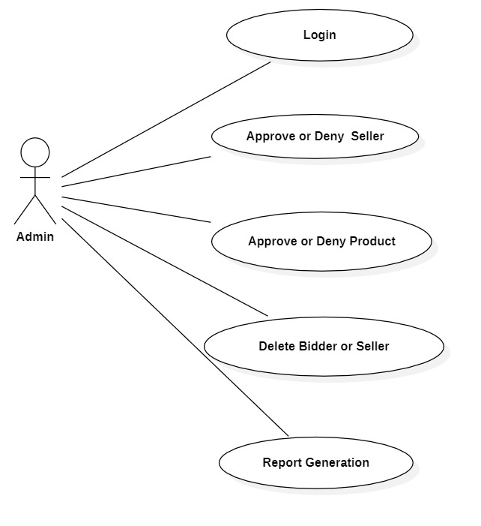

*Fig. Use case diagram for Admin*

1. In Admin use case diagram Admin is the Actor.
2. Admin can handle following use cases:
3. Login
4. Approve or Deny Seller
5. Approve or Deny Seller
6. Delete Bidder or Seller

**Seller:**

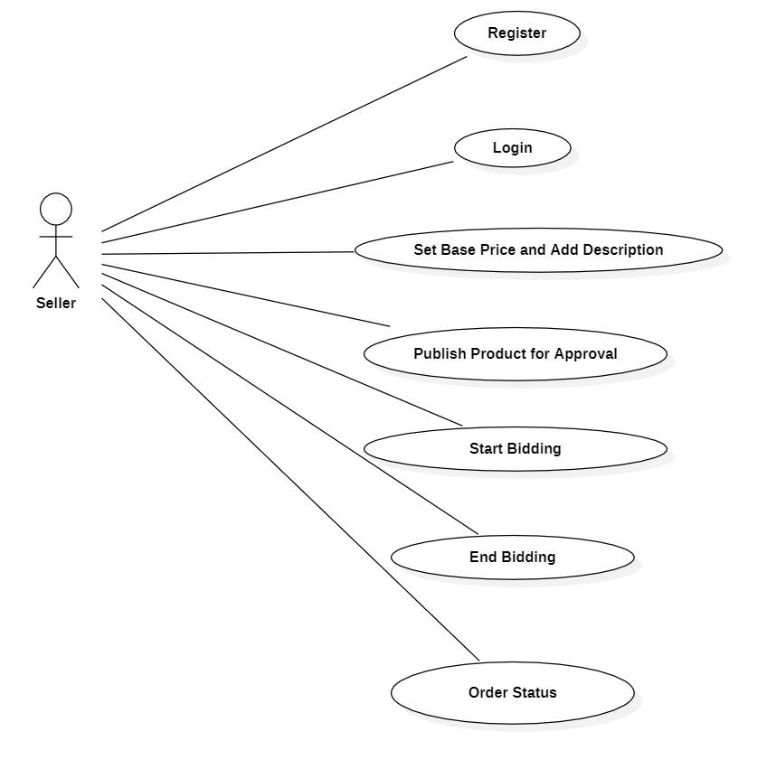

*Fig. Use case diagram for Seller*

1. In Seller use case diagram Seller is the Actor.
2. Seller can handle following use cases:
3. Register
4. Login
5. Set Base Price for Product and Add Description for Product
6. Publish Product for Approval
7. Start Bidding
8. Delete Product
9. End Bidding
10. Order Status

**Bidder:**

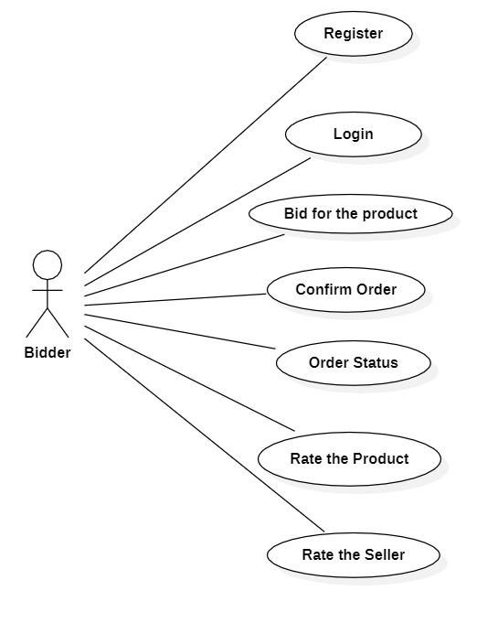

*Fig. Use case diagram for Bidder*

1. In Bidder use case diagram Bidder is the Actor**.**
2. Bidder can handle following use cases:
3. Register
4. Login
5. Search Product
6. Bid for the Product
7. Confirm Order
8. view order status
9. Rate the Product
10. Rate the Seller